Objective
During the duration of a sprint the entire team will update the scrum board to show the current status of completed work. Keeping the scrum board up-to-date is important to ensure work is progressing on schedule and that all team members are getting credit for their work.

Due Date/Time
This must be completed during the course of sprint production.

Materials
Trello user account (https://trello.com/)
Plus for Trello google chome plugin (http://www.plusfortrello.com/)
A completed sprint plan

Procedure
Teams must have already completed the “Sprint Planning with Trello” activity before this starting this activity

Step One
Open and log into Trello using the information you provided on the team contact sheet. The main Trello page should look something like below.

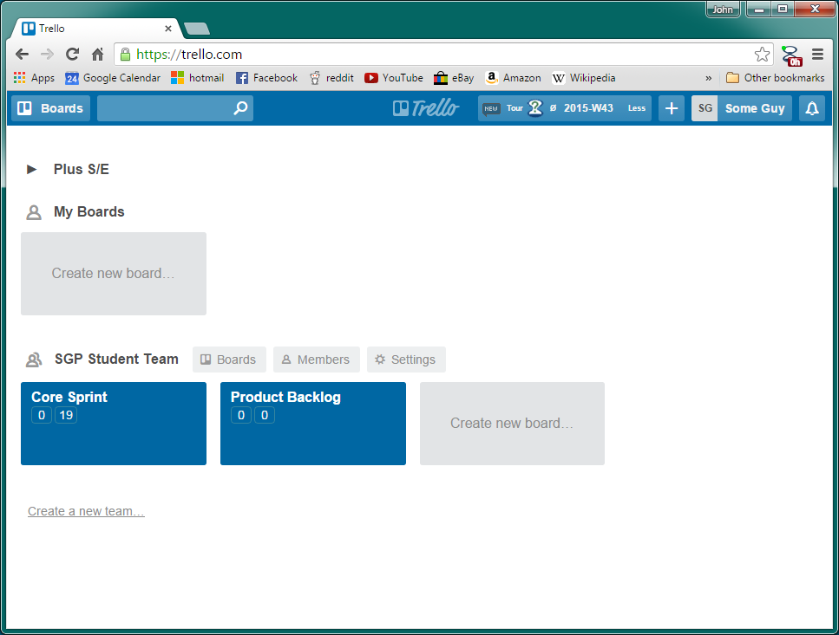

Step Two
Enter the board for the current sprint. At the beginning of a sprint all userstories should start in the backlog list indicating that no work has been completed on that userstory.

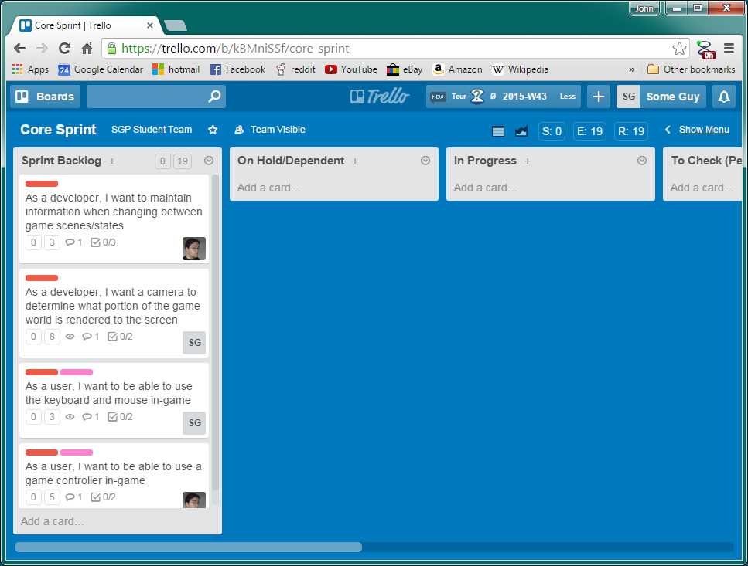

Team can orginize userstories in the backlog o help with workflow. It is highly encouraged to have userstories sorted on the sprint blacklog according to owners and priorety to the end product.

Step Three
Update userstories on the board to show their status as work is completed. Click and drag a userstory dragging it to its new status to change the current status of a userstory.

Steps For each status

On hold/Dependent
If a userstory is ever found to be dependent on work from a different userstory it should be entered into the On Hold/Dependent status. Any time a userstory is entered into dependent makes sue you open the userstory and add a note explaining what it is dependent on

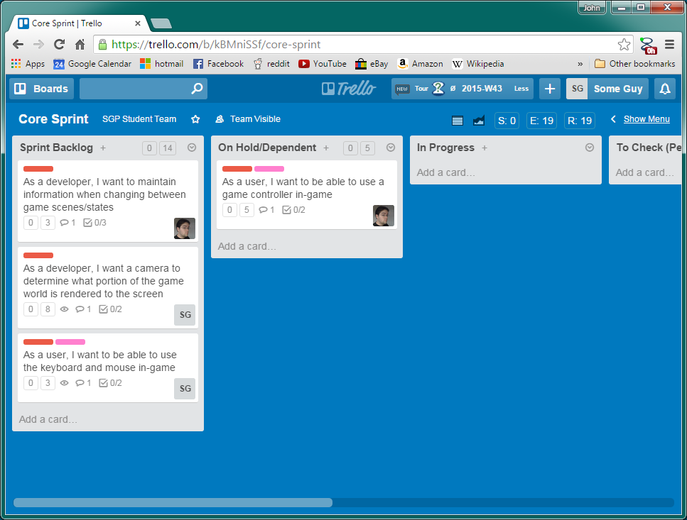

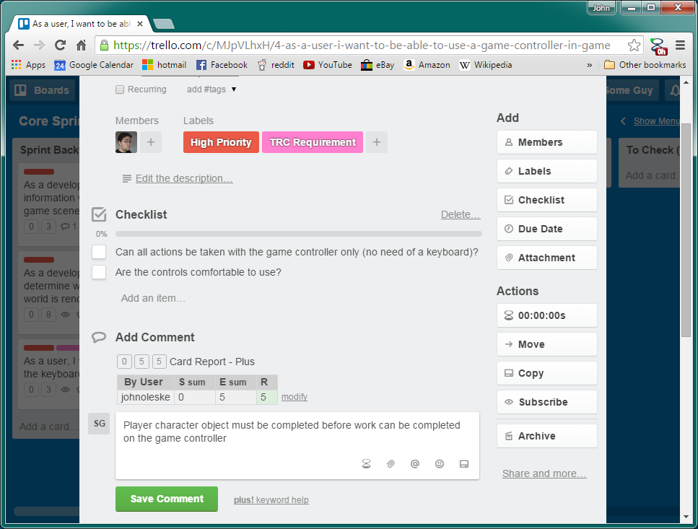

In Progress
Whenever a team member starts working on a user story the team member enters the userstory into the In Progress status.

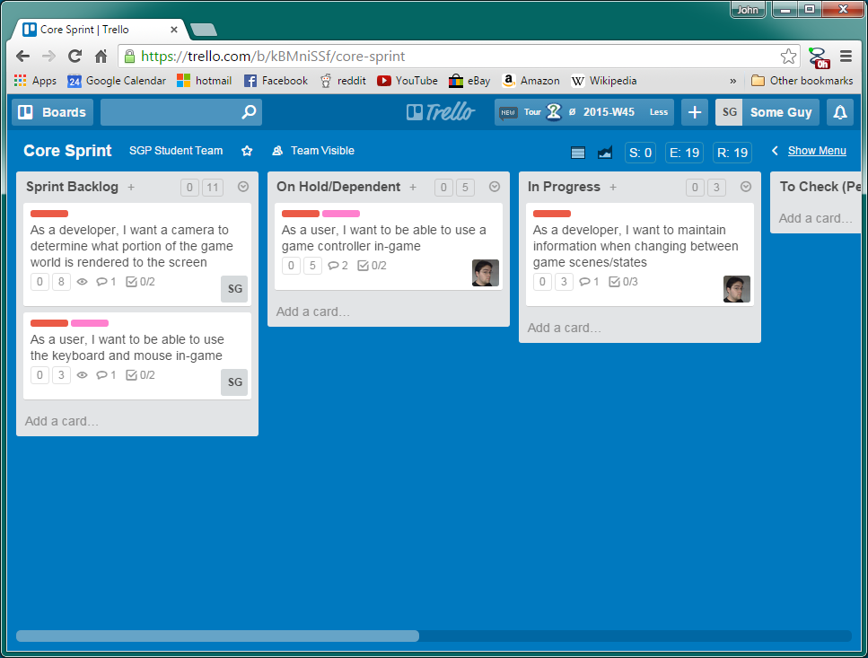

Each team member should only have one userstory in progress at a time. Team members should always continue working on a userstory once it is entered into in progress until it is completed and adding value to the product.

To Check (Peer)
When a team member believes they have completed all tasks related to a userstory that team member enters the userstory into the To Check (Peer) status

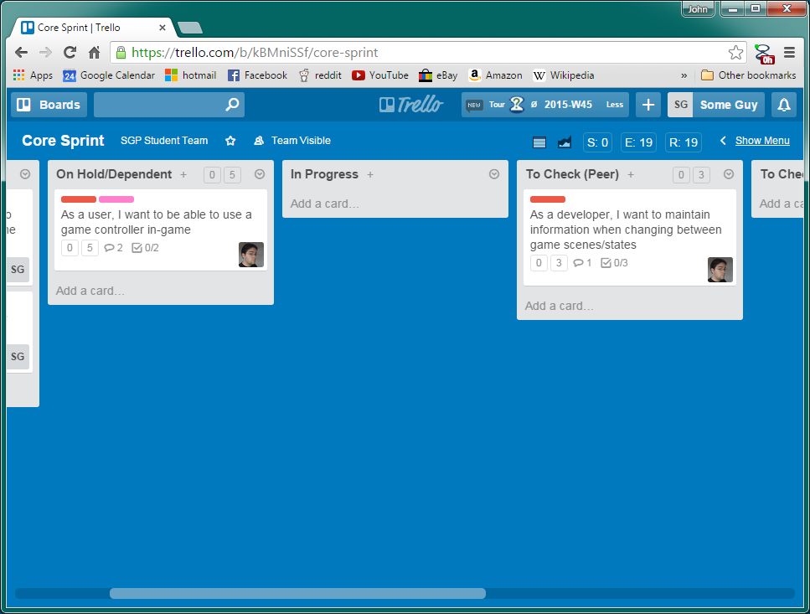

When the userstory is moved into To Check the teammember that completed the work on that userstory must enter into its comments the time spent while working on the story using a trello plus comment system.

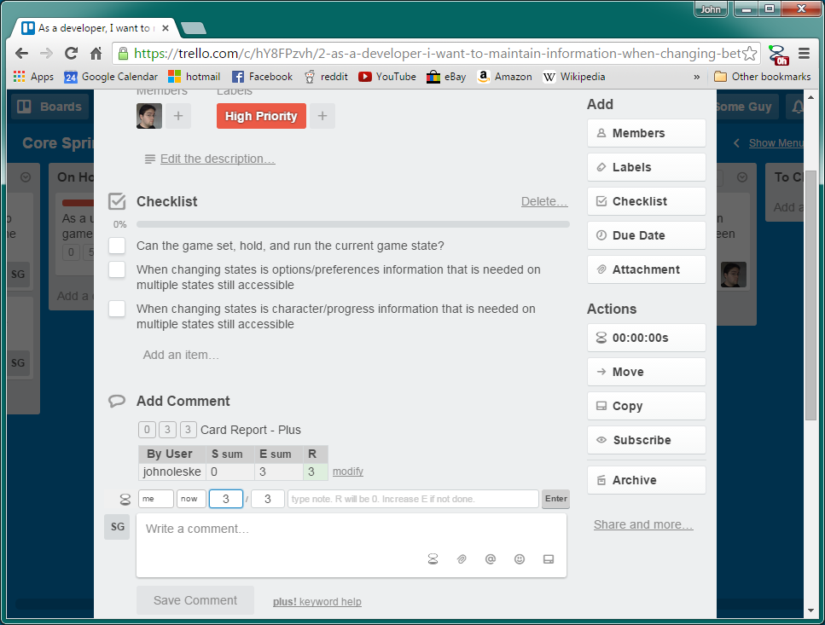

To Check (Product Owner)
User stories in the To Check (Peer) catigory are waiting for a teammember to check off on the work. Team members should spend a short amount of their time each day, while between other tasks, pulling the most recent build from the repository and peer reviewing the work that has been completed.

When the work has been checked, the peer checking off the work should level a comment on the userstory about the check off explaining the outcome of the peer review and then enter the userstory into the To Check (Product Owner) status if the sign off was complete or back in the Sprint Backlog status if there is more work yet to be completed

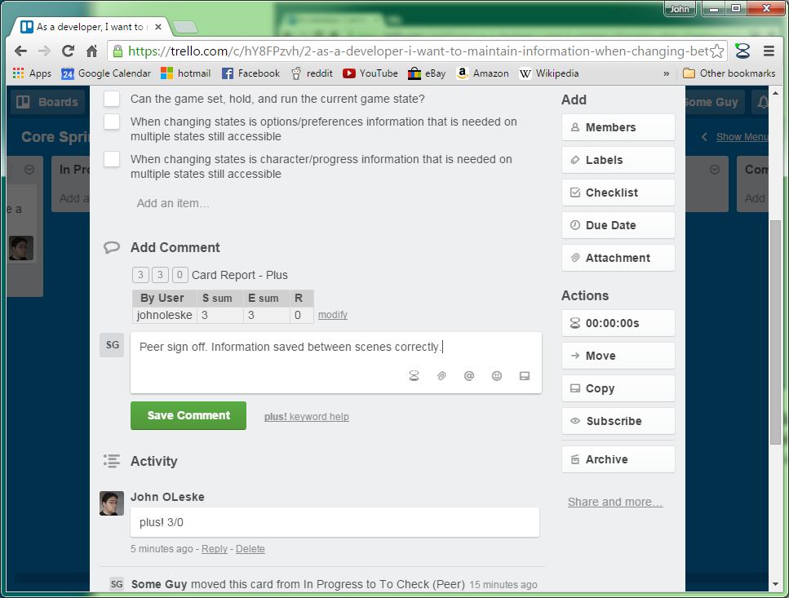

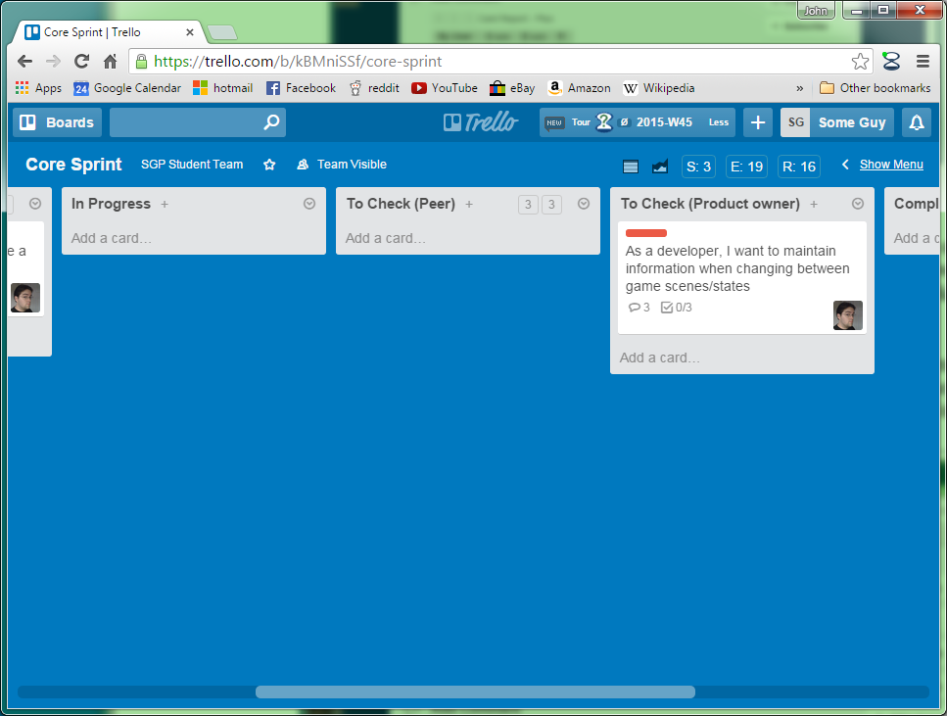

Complete
Only the product owner should be entering items into the complete status. The product owner will go through the userstories under the To Check (Product owner) status checking the boxes in the Test cases/Acceptance criteria. If all work meets with their expectations the product owner enters the userstory into the complete status.

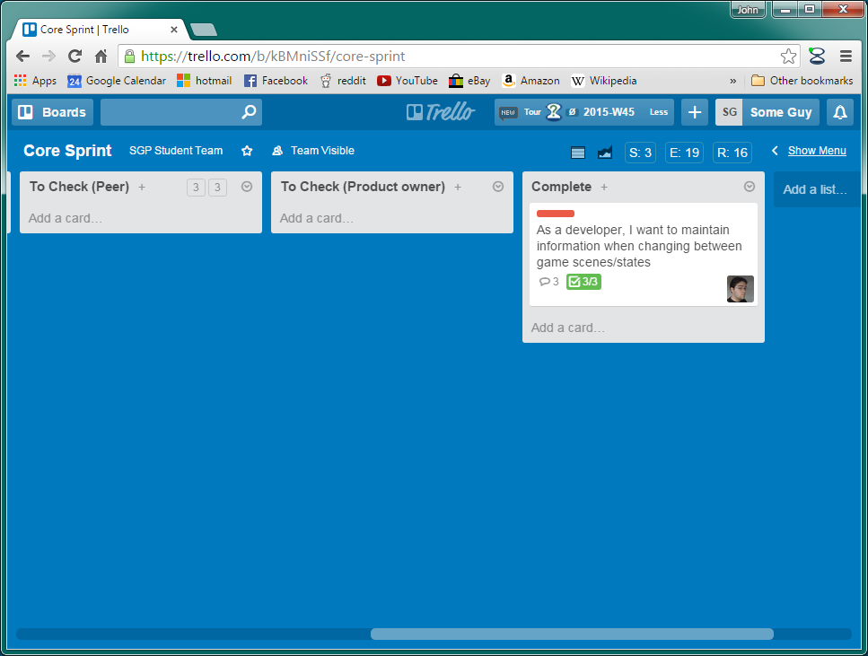

Step Four
Useful tools

On the top of the widow Trello plus provides some useful stats on the current state of the project letting teams know at a glance S: time spent on the sprint, E: total time estimated to complete sprint, and R: how much work is remaining on the sprint.

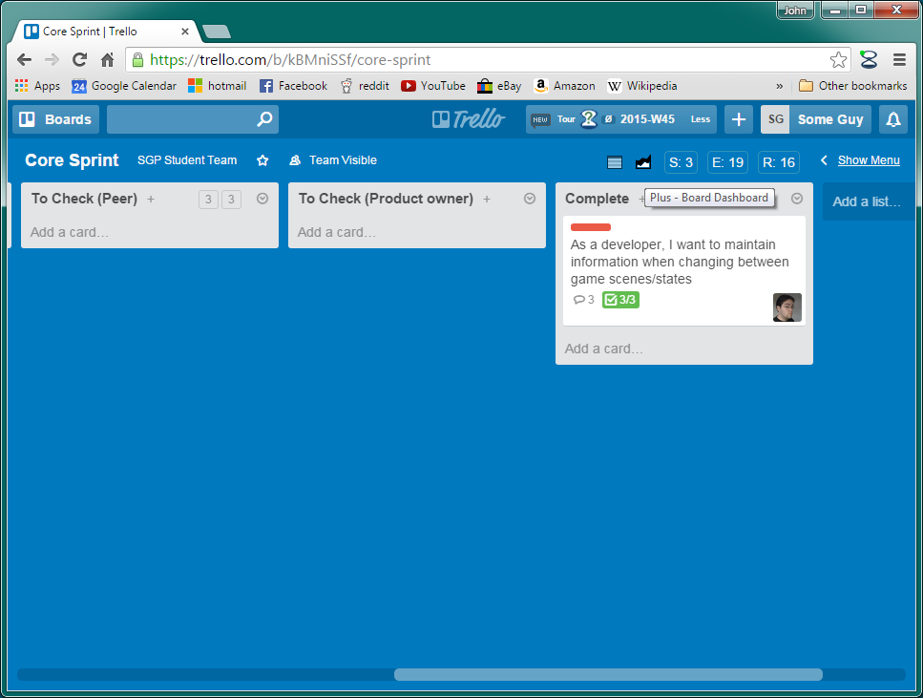
Clicking on the graph icon opens a new tab with avisual burn down of the current sprint progress.
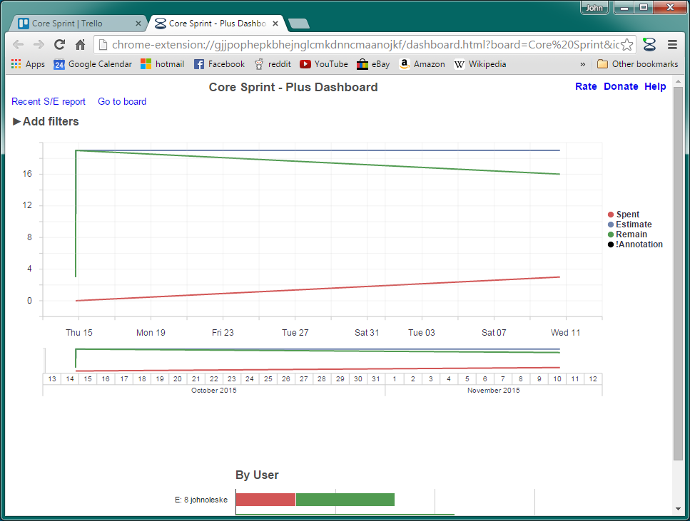

Work submitted:
Sprint tracking should be consistently maintained throughout each sprint.

